# Market Web Portal Manual

The web portal is used for importing fees and displaying analytical information about them. The web portal provides cross platform compatibility with a simple and easy to use fluid UI.

The portal is comprised of two pages called Prices and Upload. These pages can be accessed by using the main menu at the top right corner shown below in [img1].



**[img1]**

The first page provides a dashboard composed of 2 main UI components. The first component is a horizontal bar chart and the second component is a date range picker. Both are shown below in [img2].

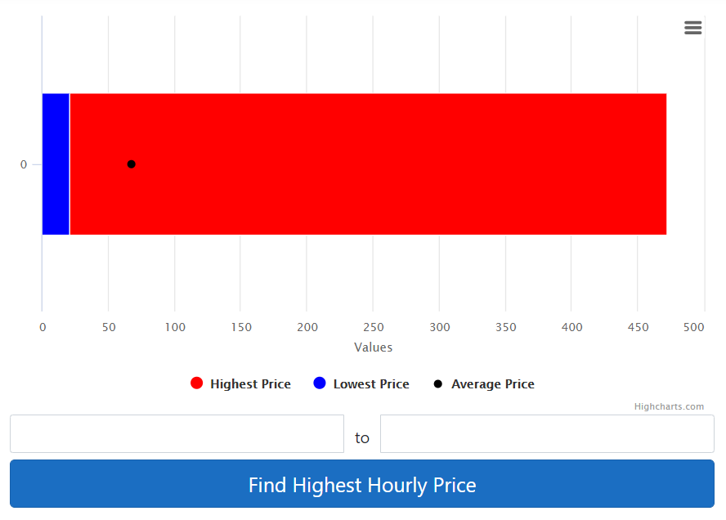

**[img2]**

The bar chart is capable of displaying the following information:

* The lowest price shown as a blue bar. By hovering over the blue bar, the lowest price will be shown in a tooltip as shown below in [img3].

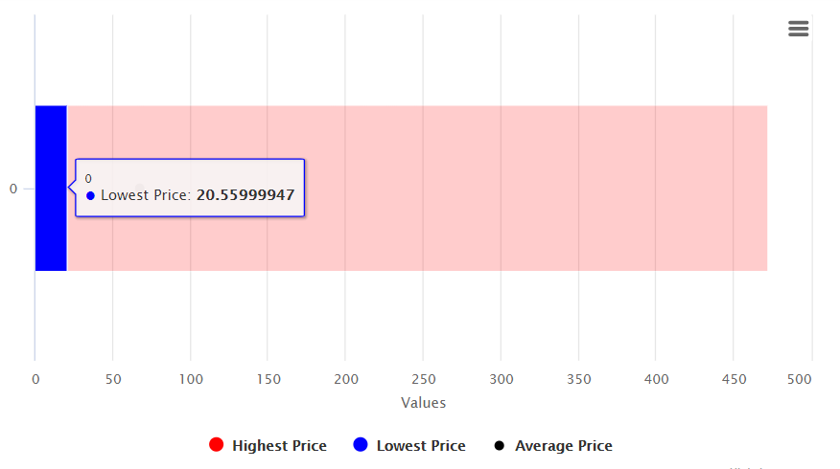

**[img3]**

* The highest price shown as a red bar. By hovering over the red bar, the highest price will be shown in a tooltip as shown below in [img4].

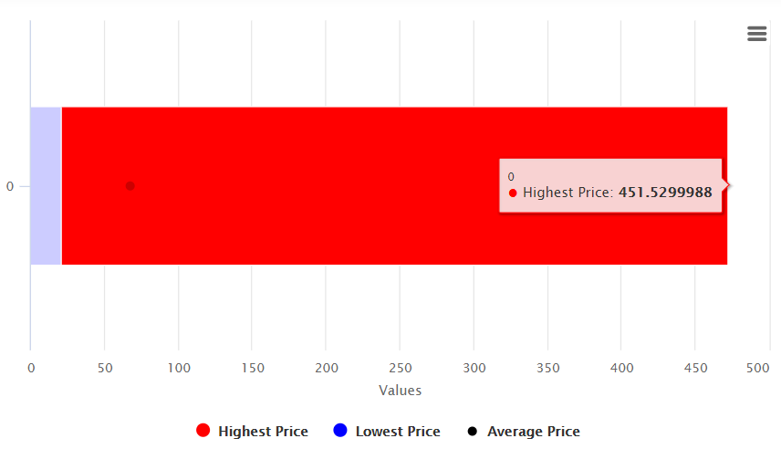

**[img4]**

* The average price shown as a dot in the bar chart. By hovering over the dot in the bar chart, the average price will be shown in a tooltip as shown below in [img5].

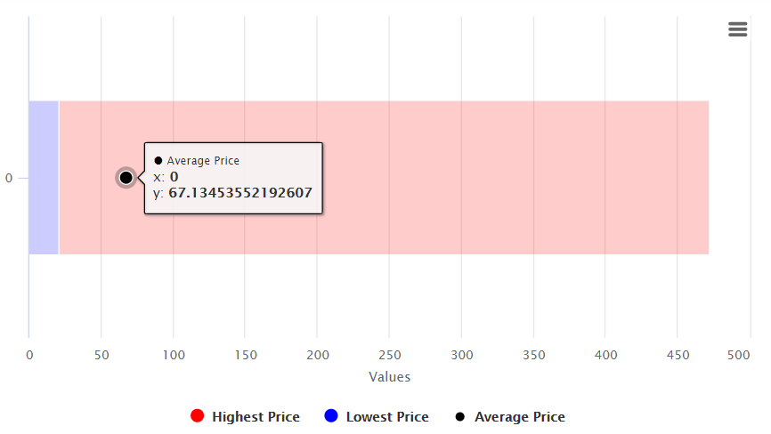

**[img5]**

The bar chart also provides a sandwich menu at the top right corner providing a full screen mode and a variety of downloading and exporting features.

If the bar chart is unable to find any prices, it will be empty as shown below in [img6].

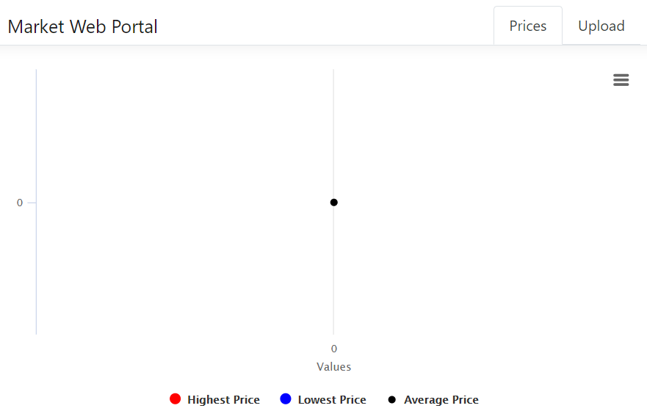

**[img6]**

The date range picker can be used to provide Start and End dates as shown in [img7] which will be used to retrieve the highest hourly price when the blue button below is clicked. To provide a date, a date picker will be shown automatically when a textbox is clicked. Dates can be also changed directly in textboxes without using date pickers.

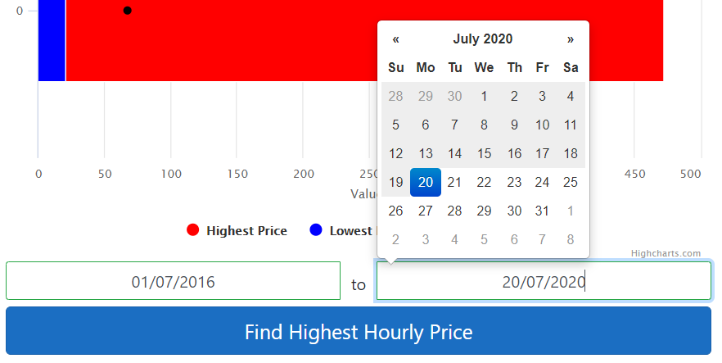

**[img7]**

By clicking the “Find Highest Hourly Price” button, the following information will be displayed below the button as shown in [img8].

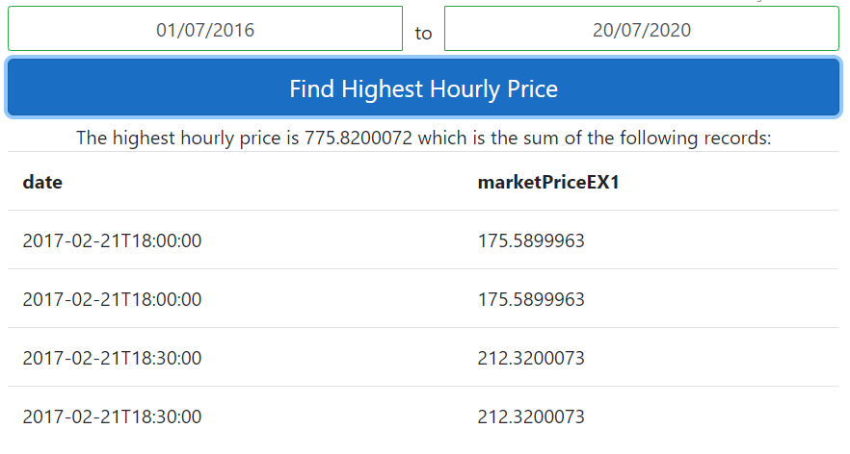

**[img8]**

If there are no prices for a given date range, the following output message will be displayed below the button as shown in [img9].



**[img9]**

To upload prices, click on Upload tab in the main menu and provide a file with the .CSV file extension. The file has to provide 2 columns:

1. Column name “Date” with its format set to Date as shown below in [img9].

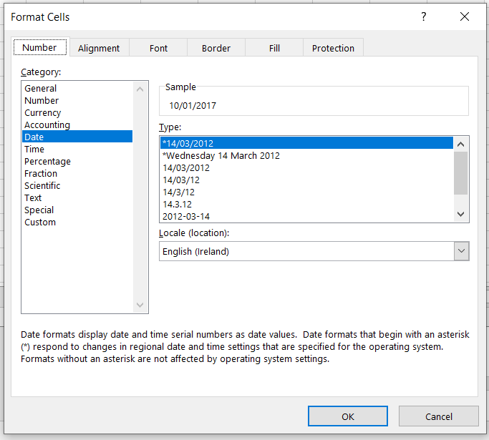

**[img10]**

1. Column name “Market Price EX1” with its format set to General as shown below in [img11].

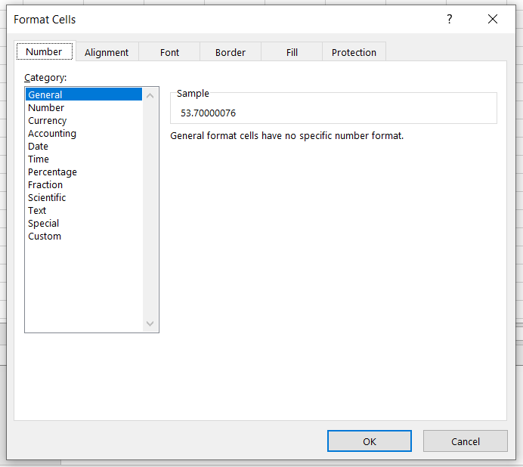

**[img11]**

When the file is provided, click the Upload button to import prices. When prices are imported the following message will be displayed as shown in [img12]

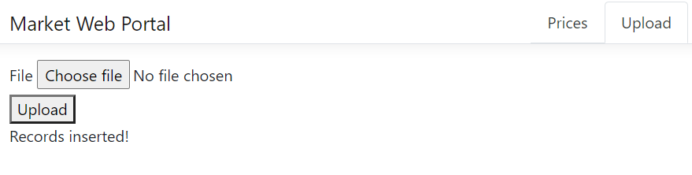

**[img12]**